Organathon Sponsor Form
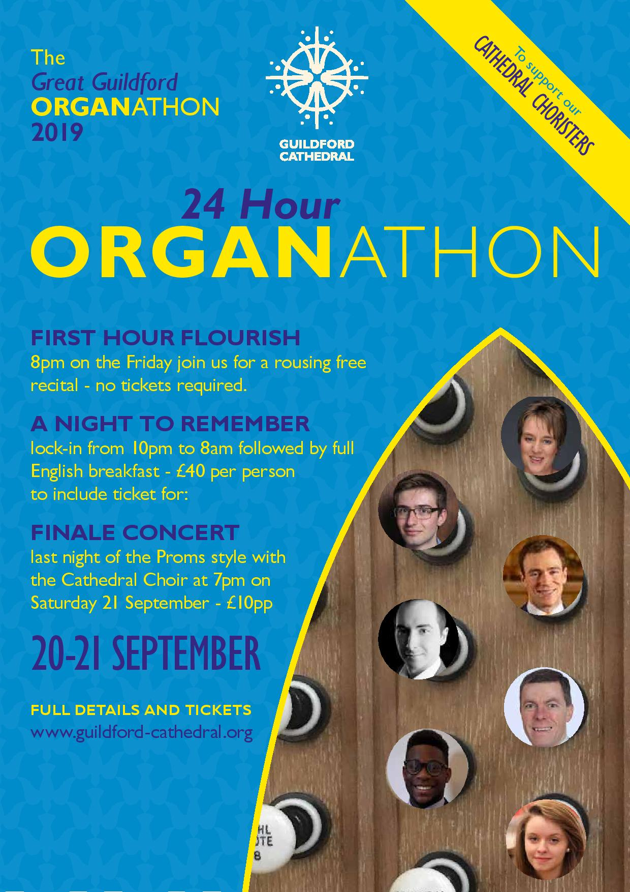
Organathon Sponsor Form

The 24 Hour Organathon takes place from 8pm on Friday 20 September finishing with the Last Night of the Proms Concert between 7pm-8pm on Saturday 21 September.

Sponsoring the whole event

You can support this event by sponsoring our Just Giving Page at https://www.justgiving.com/fundraising/cathedral-organathon or you can submit your sponsorship with this form using cash, cheque, BACS or credit / debit card

Methods of payment:
- cash or cheque simply complete this form and put it with your sponsorship into an envelope
- BACS please tick the BACS box and make the payment direct into our bank using the reference ORGAN and your surname, and complete that same reference on this form so that the two can be matched together (Sort Code: 60-09-50: Account Number: 58063021)

All forms should be put in the Organathon Box on the Guides Desk. This will be emptied daily.

Name: …………………………………………………………………….…………………….

Address: ……………………………………………………………………………………...…

………………………………………………………………………..…………………………

Post Code: ……………………………………………………………...………………………

Telephone: …………………………….. Email: ………………………………………………

I wish to sponsor the 24 hour Organathon with the sum of £ ………………………….…….

Method of payment: CASH CHEQUE BACS

BACS Reference …………………………………………………..……………………………

Make your donation worth 25% more, at no extra cost to you. If you are a UK taxpayer, simply tick the Gift Aid box. Your home address is needed to identify you as a current UK taxpayer.

I want to Gift Aid my donation and any donations I make in the future of have made in the past 4 years to Guildford Cathedral. I am a UK taxpayer and understand that if I pay less Income Tax and / or Capital Gains Tax than the amount of Gift Aid claimed on my donations in that tax year it is my responsibility to pay any difference.

TICK THIS BOX to Gift Aid your donation

Sponsor a Piece

The Organists have all submitted items that are in their repertoire that they would be delighted if you were happy to sponsor for them to play. The repertoire list is available on our website or in the booklet on the Guides Desk.

The minimum sponsorship for a piece should be £10, but you can do more if you think it is worth it!

Methods of payment:
- cash or cheque simply complete this form and put it with your sponsorship into an envelope
- BACS please tick the BACS box and make the payment direct into our bank using the reference ORGAN and your surname, and complete that same reference on this form so that the two can be matched together (Sort Code: 60-09-50: Account Number: 58063021)

All forms should be put in the Organathon Box on the Guides Desk. This will be emptied daily.

All Sponsor a Piece requests should be submitted by midday on Friday 20 September, into the Organathon Box on the Guides Desk, to allow the Organists to plan their 2 hours.

Many of the Organists are playing more than once, so please indicate if you have a preferred time slot that you would like your sponsored piece to be played in, ie if Katherine is playing 12am – 2am, 6am – 8am and 4pm – 5pm, please indicate which is your preferred time slot for your piece to be played so you have an opportunity to hear it.
There is no guarantee that the time preference will be met, however if your piece is played the sponsorship will be accepted.

Name: …………………………………………………………………….…………………….

Address: ……………………………………………………………………………………...…

………………………………………………………………………..…………………………

Post Code: ……………………………………………………………...………………………

Telephone: …………………………….. Email: ………………………………………………

Method of payment: CASH CHEQUE BACS

BACS Reference …………………………………………………..……………………………

Name of Organist …………………………………………………………………………………………..

Name of Piece requested …………………………………………………………………………………..

Preferred time slot for piece to be played ………………………………………………………………….

Amount of sponsorship offered for playing this piece ……………………………………………………...

There is no guarantee that the time preference will be met, however if your piece is played the sponsorship will be accepted.

Any details submitted on this form will be used solely for the purposes of the administering and collecting of sponsorship for the 24 Hour Organathon. Your details will not be used for any other purpose or shared with third party organisations.
